Exercise 1: Mocking and Stubbing

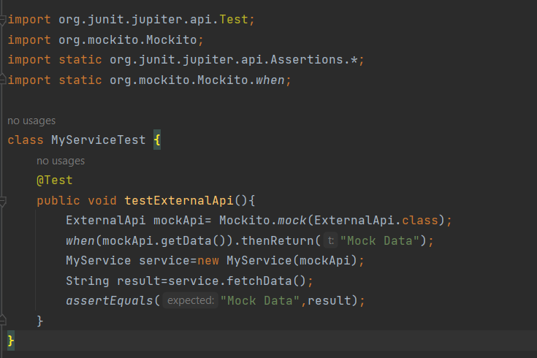

Output:

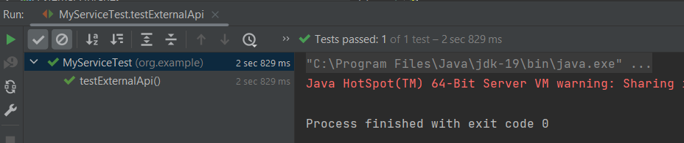

Exercise 2: Verifying Interactions

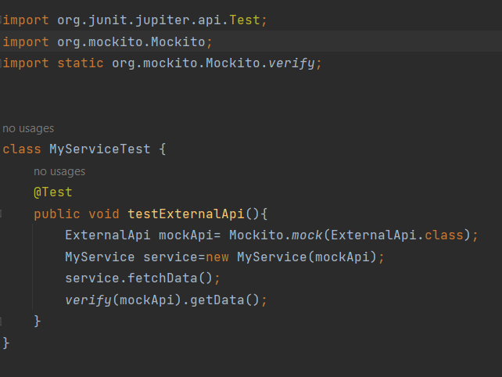

Output:

